Name:____________________________________________
Class: ________________ Number: ________________

Measuring Length

First, guess the length in centimetres of the crayons and the bus. Write your guesses.
Next, measure the length. Write your answers.
Guess: __________
Answer: __________
Guess: __________
Answer: __________
Answer: __________
Guess: __________
Guess: __________
Answer: __________
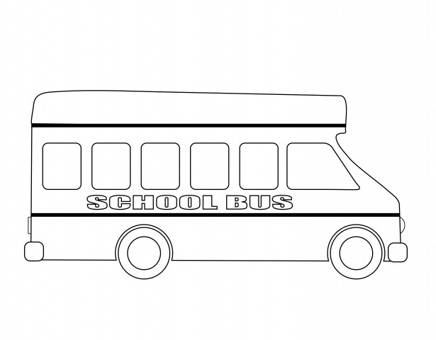
Guess: __________
Answer: __________
Guess: __________
Answer: __________

